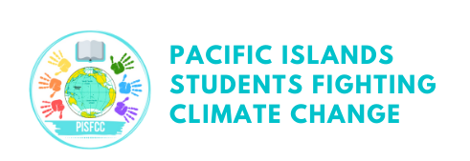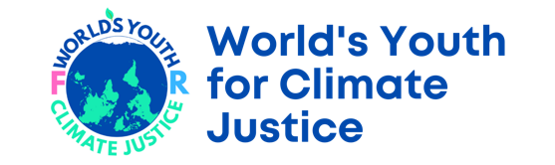

Youth Celebrate Successful UN Vote calling for International Court of Justice Opinion on Climate and Human Rights

29/3/2023, New York/Port Vila
The United Nations General Assembly has voted to support the Government of Vanuatu’s proposal for an advisory opinion from the International Court of Justice on the obligations of States on climate change. More than 130 countries came together to co-sponsor the initiative in a show of global solidarity on climate.
Pacific youth, led by Pacific Island Students Fighting Climate Change (PISFCC) and the Worlds Youth for Climate Justice (WYCJ), have celebrated the vote and called for more action to save the planet and protect the most vulnerable people. PISFCC was the driving force behind the civil society campaign, with the idea hatched in a Vanuatu class room four years ago.
The International Court of Justice will now hold hearings and hear evidence on the obligations of states in respect to climate change, with a view to handing down an advisory opinion in 2024.
Cynthia Houniuhi, Solomon Islands based President of Pacific Island Students Fighting Climate Change (PISFCC).
“We are just ecstatic that the world has listened to the Pacific Youth and has chosen to take action. From what started in a Pacific classroom four years ago.
“We in the Pacific live the climate crisis. My home country Solomon Islands is struggling. Through no fault of our own, we are living with devastating tropical cyclones, flooding, biodiversity loss and sea level rise. The intensity and frequency of it is increasing each time. We have contributed the least to the global emissions that are drowning our land.
“As young people, the world’s failure to stop planet killing emissions is not a theoretical problem. It is our present and it is our future that is being sold out. The vote in the United Nations is a step in the right direction for climate justice.
Nicole Ponce (Philippines), Asian Front Coordinator - Worlds Youth for Climate Justice
“We thank all countries for their support, especially those countries around the world that joined with Vanuatu as cosponsors. We also extend deep thanks to the Government of Vanuatu and all those who have been working to make what started as a thought in a classroom to become reality.
“While this is no silver bullet to the climate crisis it is a huge step forward in international law. We urge countries to engage with the process and to increase their climate ambitions.
Mert Kumru (Netherlands), European Front Coordinator - Worlds Youth for Climate Justice
Importantly, the court will be looking at issues of human rights and intergenerational equity which have been largely ignored by the current system.
No one can dispute that states have an obligation to take effective measures to prevent and redress these climate impacts, mitigate climate change, and to ensure that everyone is able to adapt to the climate crisis. But somehow, the process seems stuck. This request for an advisory opinion aims to be the catalyst in encouraging greater ambition within existing processes.
Jose Rodriguez (Costa Rica), Front Coordinator Latin America and the Caribbean – World’s Youth for Climate Justice

“More than 40 youth movements and 58 civil society organizations from Latin America have joined the world’s youth in raising awareness on the adverse impact of climate change on the full enjoyment of human rights. We commend Costa Rica's leadership in this process and are inspired by the regional commitment to seek legal clarity on these critical issues. Human rights violations caused by climate change disproportionately affect indigenous peoples, women, youth, and historically discriminated populations in Latin America. To address these inequities, in the pursuit of climate justice, we will work to facilitate that those most affected by climate change are heard by the ICJ”.

Khulekani Magwaza, African Front Coordinator – World’s Youth for Climate Justice
“This is a very big achievement, especially for my people in Africa. Recently I hosted a regional workshop on climate change and human rights in Johannesburg, one of the general feeling from the participants, campaigners, was that it very concerning that the climate change legal frameworks that currently exist are not able to demonstrate a powerfully enforceable law to protect the rights of innocent people, this is obviously for many countries in Africa, the Pacific islands and the world, so we should definitely celebrate the vote for ICJ to provide Advisory Opinion.”

Vishal Prasad, Campaigner – Pacific Islands Students Fighting Climate Change
“This isn’t the end of our campaign for climate justice. The court process will unfold, taking evidence from around the world. The real work begins in applying whatever the court advisory opinion says in domestic law, especially in countries that continue to drive the climate crisis with their toxic emissions.

Note to Editors:

World’s Youth for Climate Justice
World’s Youth for Climate Justice (WYCJ) is a youth-led movement bringing the world’s biggest problem to the world’s highest court. WYCJ has campaigners on all continents across the world who have played a vital role spurring the resolution to the United Nations General Assembly.
WYCJ website: www.wy4cj.org

Pacific Islands Students Fighting Climate Change
Pacific Islands Students Fighting Climate Change is a youth-led organisation that initiated the ICJAO campaign in 2019 and since then has led the global civil society and youth campaigns.
PISFCC Website – www.pisfcc.org

Media Contact – Mathew Hilton, matthew.hilton@gsccnetwork.org

